**Please note**: **This form must be emailed to the Estates Management Helpdesk at** [**ems-helpdesk@essex.ac.uk**](mailto:ems-helpdesk@essex.ac.uk) **at least three working days before the function date. You will receive email confirmation if your event is approved. You will also need to complete an event permission form: if you expect over 70 attendees (as there is only seating for 70 people) OR if your event is not restricted to a closed group where attendees are invited or on a guest list (e.g., where you are serving members of the public).**

There are two available booking times from 25 May – 30 September: 12.00-5.00pm **or** 6.00-10.00pm

There is one available booking time from 01 October – 24 May: 12.00-5.00pm

|  |  |  |
| --- | --- | --- |
| **Name of Organiser**  Enter your full name | | **Phone number:**  Enter your contact number |
| **PRID Number**  Enter your PRID Number here | | **Email Address**  Enter your email address |
| **Name of Organisation:**  Enter ‘Private booking’, or the name of your society, team, etc | | **Address**  Enter your address |
| **Date**  Choose the date of your BBQ | **Number of Guests**  Enter the number of guests | |
| **Booking Time**  Choose a time from this list | **Will there be anyone under the age of 18 attending?**  Choose an option from this list | |

(I sign below having read and agreeing to abide by the conditions laid out overleaf)

|  |  |
| --- | --- |
| **BBQ Organiser signature**  Please sign here | **Date**  Choose today’s date |

**This section is to be completed by Estates and Campus Services - Customer Service Team ONLY**

|  |  |
| --- | --- |
| **BBQ area(s) allocated**  Enter allocated BBQ area number | **Maximum guests permitted**  Enter number of guests permitted |

**This section is to be completed by Estates and Campus Services – Security Supervisors ONLY**

There will be no objection to the above function taking place provided the organiser agrees to abide by conditions on the reverse of this sheet and any additional conditions set out

|  |  |
| --- | --- |
| **Any other conditions**  Enter any conditions to the booking here | |
| **Signed**  Please sign here | **Date**  Choose today’s date |
|  |  |

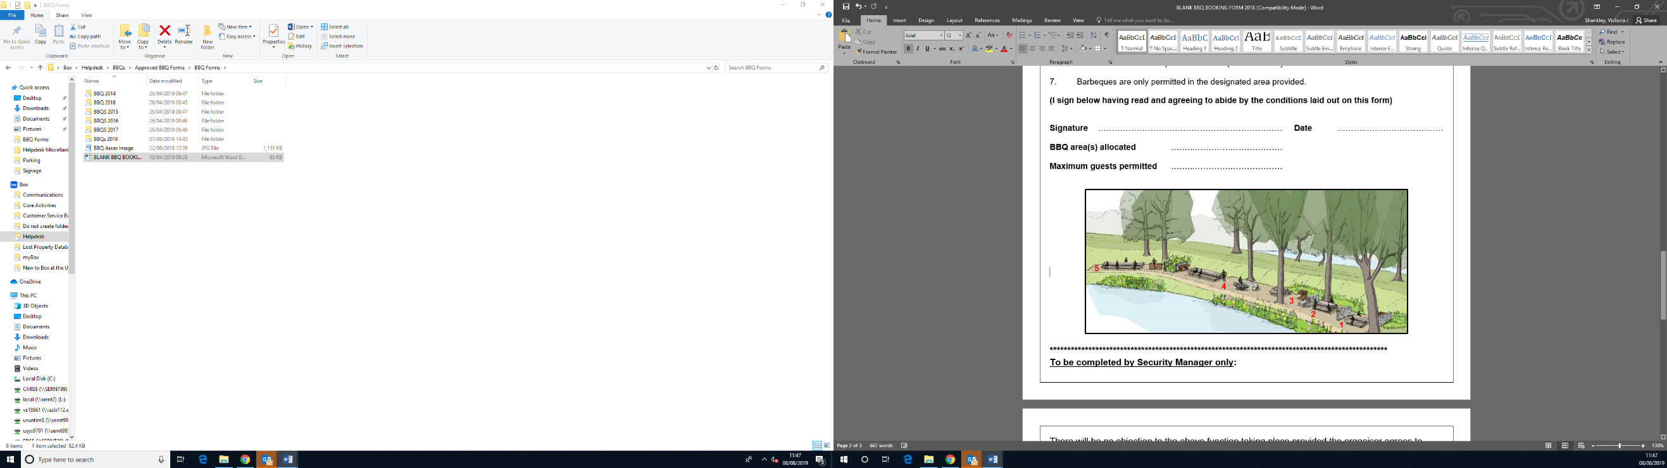

**Conditions of Barbeques**

Barbeques may be permitted to be held by any campus group provided that a member of the group is clearly identified as the ‘Organiser’ on the application form. Only members of staff or students may be the Organiser. The PRID number of the organiser must be provided.

The Organiser must give a current address and telephone number at which they may be contacted

Bookings will only be confirmed after the booking sheet has been signed on behalf of the University. The University reserves the right to cancel barbeques after a booking has been made. The University will not be liable for any costs incurred.

The University only provides a barbeque area where staff and students may hold barbeques, only after written permission has been given by the University.

Staff and students organising barbeques are advised that their own safety and the safety of persons attending the barbeque is their responsibility.

Organisers are advised to obtain insurance which would meet the legitimate claim of any person injured due to their activities.

The Organiser must take responsibility for ensuring the additional conditions listed below are complied with:

1. A fire blanket must be collected from the Information Centre on square 3 before the event and returned within an hour of the finish, the Organiser will be charged for the cost of this item should it be found missing. **Please note: Patrol staff are trained First aiders and can be contacted in an emergency on 01206 87 2222.**
2. **Music will not be permitted**
3. After the event the group must clear away all rubbish using the general waste bins provided. All BBQ items such as used disposable BBQ trays, coals etc must be disposed of in the large metal BBQ bins. If this is not done to the satisfaction of the Deputy Director Services any cost associated with cleaning the area will be charged to the Organiser
4. The sale of alcohol or food will not be permitted nor will pre-payment for alcohol or food, by means of an attendance fee or by any other means
5. The poplar trees in the lake area are known to be old and it is possible in sustained high winds that they could become unsafe. It is the responsibility of the Organiser to cancel any event if high winds are forecasted or develop on the day
6. Private vehicles are not permitted on the parkland at any time
7. Barbeques are only permitted in the designated area provided
8. Disposable BBQ’s must ONLY be used on the BBQ plinths. Do not place these on the benches or tables as this will cause damage
9. You must not remove wood from trees in the parkland for burning. This damages the parkland and green wood (from a living tree) will produce lots of smoke
10. Only coals, briquettes and wood should be burnt
11. Do not burn compressed canisters
12. Do not burn items containing materials other than wood such as old furniture
13. Do not burn your rubbish, use the bins provided
14. No liquid fuel (e.g., petrol / paraffin) to be used on the fire pit
15. Misuse of the BBQ area may result in campus Patrol Officers stopping your event.